**ECE320 Lab 3**

| **Irene Suah Lee** | **Student number: 1003180149** |
| --- | --- |
| **Laura He** | **Student number: 1003893637** |
| **Songeun You** | **Student number: 1003815794** |

**Lab Section: PRA0107**

# 

# 

# **4.2**

Color code of load: orange

*[ 1 ] Measurement Smith chart plot of load impedance versus frequency.*

51.445 + j26.36 Ω, 5.246 nH

*[ 1 ] Measurement Smith chart plot of load impedance versus frequency, de-embedded by 0.2 ns.*

29.934 - j2.18 Ω, 90.234 pF

*[ 3 ] Equivalent electrical distance (in wavelengths) at 800 MHz associated with the 0.2 ns port*

*extension. Demonstrate that this additional distance corresponds to the Smith chart*

*transformation seen in the measurement.*

λ1 = 𝑐0 / *f* = 3 × 108 / 800 MHz = 0.375m = 37.5cm

T = 1 / *f* = 1 / 800 MHz = **1.25 ns**

Finding equivalent electrical distance:

T/ 0.2ns = λ1 / λ0

1.25ns / 0.2ns = 37.5cm / λ0

λ0 = **6cm**

We can see the effect of this port extension on the Smith Chart, as the de-embedded load impedance has been moved counter-clockwise (i.e.: towards the generator) relative to its original point. This is a result of accounting for the extra length added by the 0.2ns port extension.

# **4.3**

*[ 5 ] Determination of 𝑧A by rotating 𝑧L by 𝑑0 = 3.4 cm on the Smith chart, and transformation of 𝑧A to 𝑦A on the Smith chart.*

(λ1 / 2) / λ0 = 360 / x

18.75 / 3 = 360 / x

x = 57.6°

zL = (51.45 + j26.36 Ω) / 50 = 1.0290 + j0.5272

yL = 0.8 - j0.4

zA = 1.65 + j0.15 Ω

yA = **0.6 - j0.07**

**4.4**

*[ 20 ] Design of the double stub matching network for the load provided using a Smith chart. Show the calculated stub lengths 𝑙1 and 𝑙2 in terms of wavelengths, and 𝑙1 and 𝑙2 in terms of cm. Determine all lengths for both fundamental solutions.*

(See Smith Chart on next page)

Theoretical solution 1

l1 = 0.1 λ = 3.75cm

l2 = 0.17 λ = 6.375cm

(Where λ = 37.5cm)

Theoretical solution 2

l1 = 0.449 λ = 16.84cm

l2 = 0.46 λ = 17.25cm

(Where λ = 37.5cm)

Note: you can obtain “new” solutions by adding nλ/2 to the lengths of the two solutions above, since the values are periodic in wavelength.

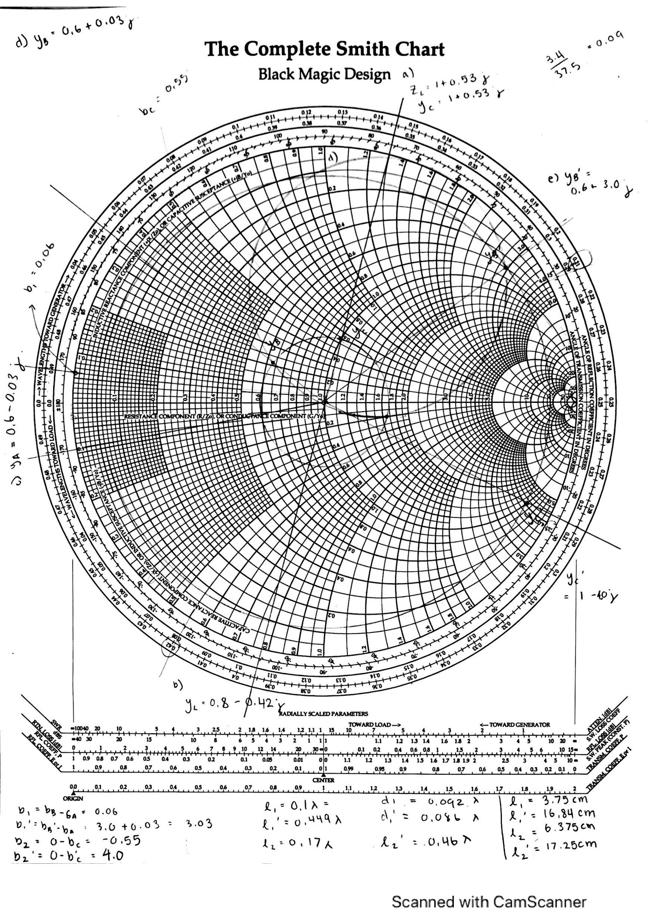

# **4.5**

*[ 3 ] Experimental determination of the final stub lengths for both fundamental solutions to*

*achieve a match between the load and the line.*

Solution 1

l1 = 3.9cm

l2 = 8.1cm

Solution 2

l1 = 18.1cm

l2 = 17.9cm

*[ 2 ] Measurement Smith chart plots of the matched load for both fundamental solutions.*

Measured Smith Chart for Solution 1

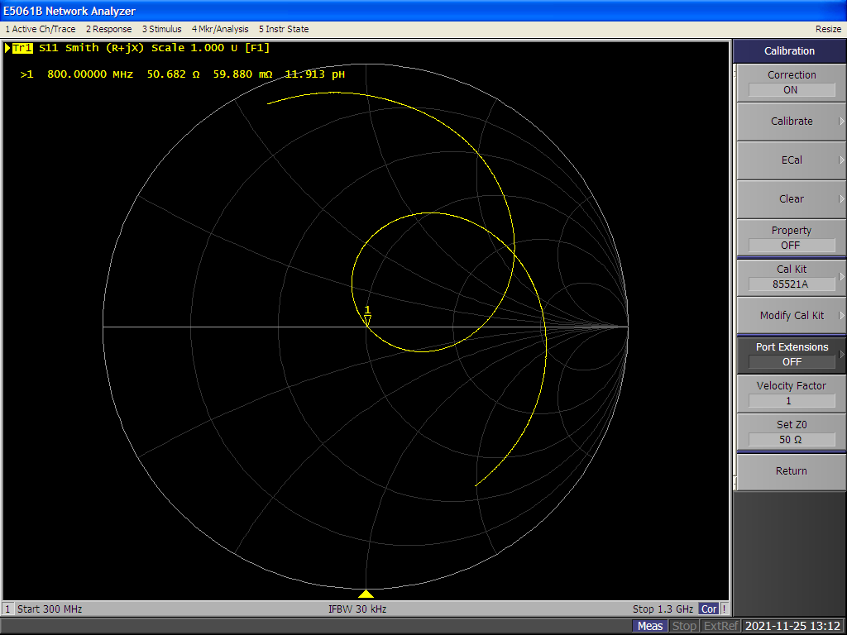

Measured Smith Chart for Solution 2

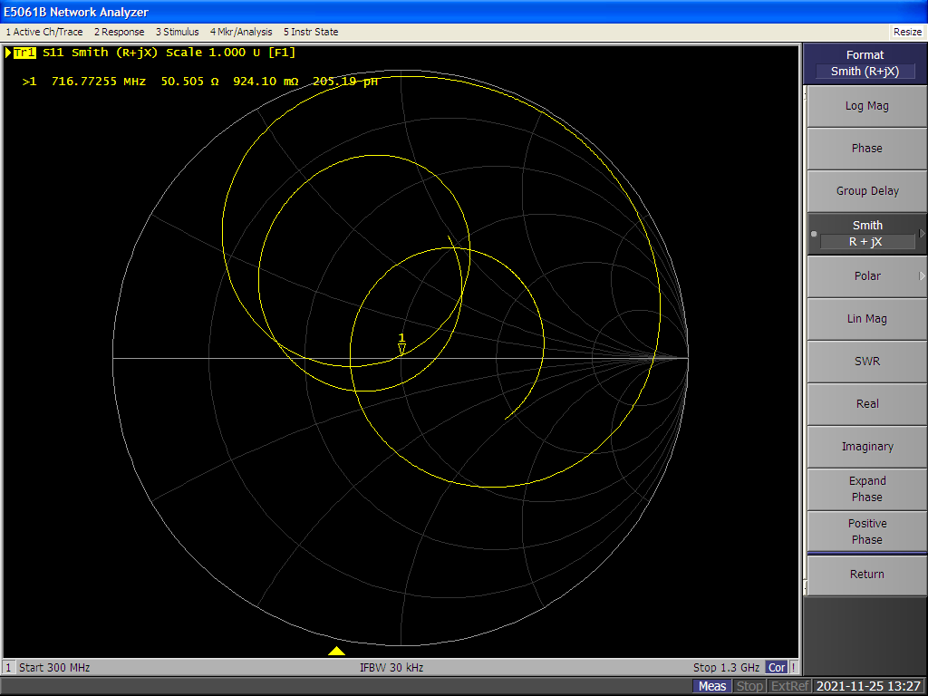

# 

# **4.6**

*[ 5 ] Measurement plot of the final VSWR and measurement of bandwidth for both funda-*

*mental solutions. Relate the VSWR bandwidth criteria to the reflection coefficient and*

*its value in decibels (20 log|Γ|). Give some reason for the bandwidth limitation.*

Bandwidth plot of solution 1

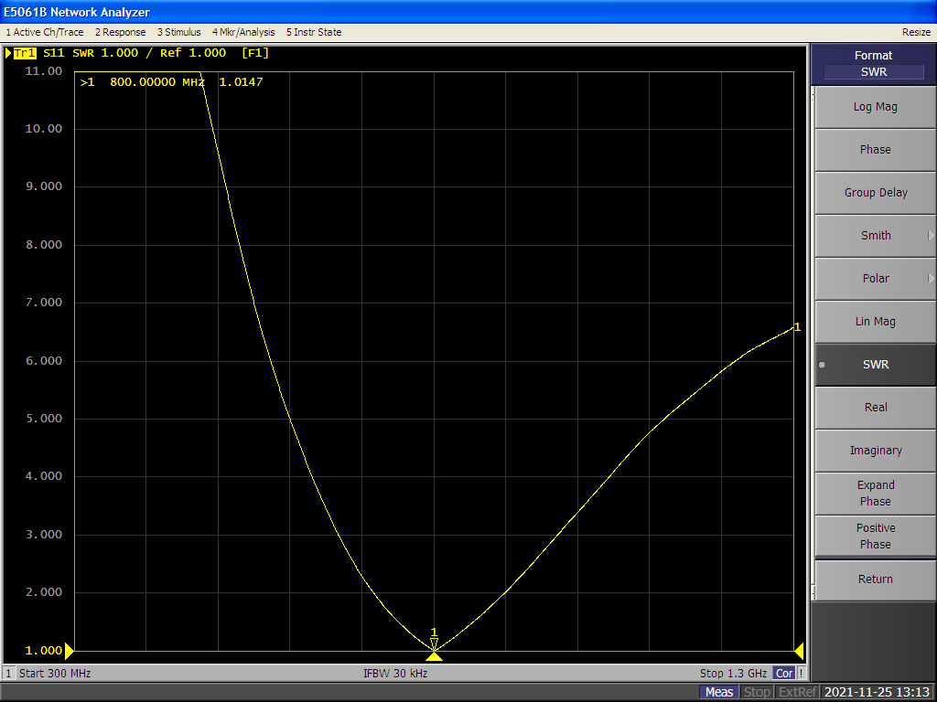

Bandwidth plot of solution 2

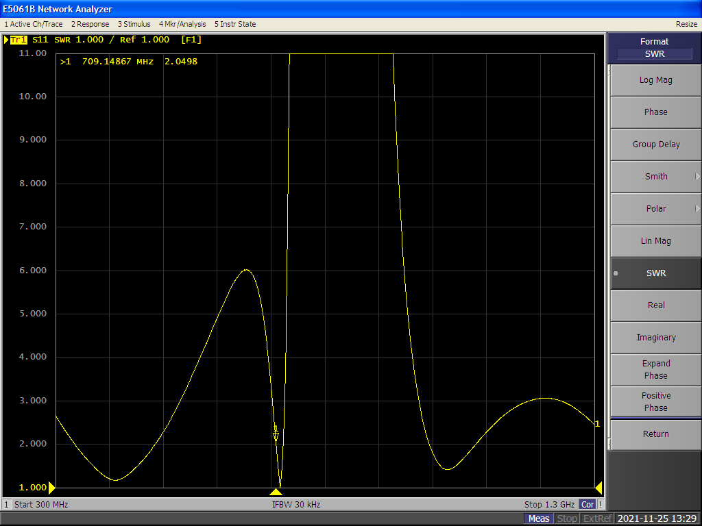

Solution 1 Bandwidth Range: 716.8MHz - 898.5MHz (difference of 181.7MHz)

Solution 2 Bandwidth Range: 709.1MHz - 721.9MHz (difference of 12.8MHz)

When the VSWR bandwidth criteria is less than 2, we use the VSWR formula defined below:

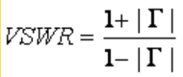

to get the reflection coefficient Γ = ⅓ . This implies that the VSWR specification restricts the reflection coefficient Γ < ⅓ . In addition, we can use Γ to determine how much power is reflected using the formula:



The reflected power (dB) is approximately -10dB, meaning 10% of the power is reflected.

The bandwidth limitation occurs because of the length of the stub used for matching. Shorter stubs have larger bandwidths because there is less room for variation in transmission line parameters such as the input impedance. Since the input impedance depends on β, which in turn depends on the per-unit-length inductance and capacitance L’ and C’, the longer a transmission line, the greater the chances of variance in L’ and C’.

*[ 5 ] Discussion of how the measured results compare to the theoretically calculated ones;*

*outline any potential sources of errors.*

Comparing the theoretical and measured values of l1 and l2 in solutions 1 and 2 (denoted as l1, l2, l1’ and l2’, respectively), we can see that the measured and theoretical values of l1, l1’, and l2’ are within 7% of each other. The value of l2 differs more, by around 21%. Overall, this indicates that the theoretical and measured values are quite good.

Possible sources of error in determining the measured values can arise from the length of the adapter that we used to connect the VNA cable to the first stub port. Since we needed to use two adapters, this extra length may have impacted the final readings.

Another source of error can be found in the procedure for calculating the theoretical values, namely, possible errors in reading the Smith Chart. The Smith Chart’s axis labels do not have a sufficiently high precision, so we often made rounding decisions when reading the values from the chart. For example, if a point fell between two circles of constant conductance, we rounded to the closest circle’s value. These types of rounding errors could propagate through the calculations we performed on the Smith Chart.